Title: **Binary Conversion and Timers** Worksheet: 3

Course: Introduction to Automation Unit: Introduction to PLC CLO: 4

Name ____________________________ Grade _______ Date ______________

**Objectives**

1. Student shall calculate a binary number given its equivalent value in decimal form.
2. Student shall calculate a decimal number given its equivalent value in binary form.
3. Student shall determine the state of timer output bits given specific information.

**Assessment**

Students shall demonstrate a comprehension of the objectives listed above by scoring a minimum of 75% on this Worksheet. Grading shall be based on the answer key.

**Instructions**

Convert the following decimal numbers to their binary equivalents.

1. 3310 ________ ________2
2. 1110 ________ ________2
3. 5110 ________ ________2
4. 510 ________ ________2
5. 12110 ________ ________2
6. 1410 ________ ________2
7. 8310 ________ ________2
8. 910 ________ ________2
9. 9910 ________ ________2
10. 20110 ________ ________2

**Instructions**

Convert the following binary number to the decimal equivalent.

1. 1010 1110 ________10
2. 0010 1110 ________10
3. 1001 1011 ________10
4. 0111 1101 ________10
5. 1011 1001 ________10
6. 1001 1001 ________10
7. 0111 1111 ________10
8. 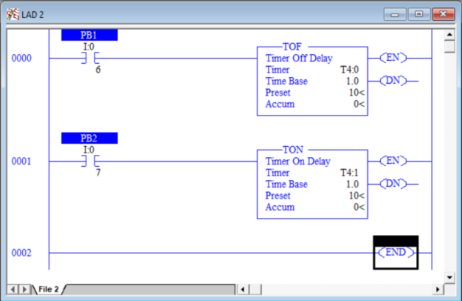0001 0010 ________10
9. 0101 0001 ________10
10. 1000 1010 ________10

**Instructions**

Answer the following questions based on the ladder logic shown in the following program. PB1 is a NC pushbutton and PB2 is a NO pushbutton.

|  |  |
| --- | --- |
| If PB1 is pressed and the *Accum < Preset*;   1. What is the state of T4.0/DN?    1. True    2. False 2. What is the state of T4.0/TT? 3. True 4. False 5. What is the state of T4.0/EN? 6. True 7. False   If PB1 is pressed and the *Accum = Preset*;   1. What is the state of T4.0/DN?    1. True    2. False 2. What is the state of T4.0/TT? 3. True 4. False 5. What is the state of T4.0/EN? 6. True 7. False | If PB2 is pressed and the *Accum < Preset*;   1. What is the state of T4.1/DN? 2. True 3. False 4. What is the state of T4.1/TT? 5. True 6. False 7. What is the state of T4.1/EN? 8. True 9. False   If PB2 is pressed and the *Accum = Preset*;   1. What is the state of T4.1/DN? 2. True 3. False 4. What is the state of T4.1/TT? 5. True 6. False 7. What is the state of T4.1/EN? 8. True 9. False |